**Stage 2: Planning and Modelling**

|  |  |  |  |
| --- | --- | --- | --- |
| Project Abbrev & Name | **GFM: An enhanced Grammatical Framework minibar** | Client + email | **Zola Mahlaza** [**zola.mahlaza@uct.ac.za**](mailto:zola.mahlaza@uct.ac.za) |
| Date | **11 August 2023** | Tutor + email | **Hamza Amir** [**amrham001@myuct.ac.za**](mailto:amrham001@myuct.ac.za) |
| Team Members | **KPPDEA001, Dean Kopping,** [**kppdea001@myuct.ac.za**](mailto:kppdea001@myuct.ac.za) | | |
|  | **FRNMOD001, Modjadji Francis,** [**frnmod001@myuct.ac.za**](mailto:frnmod001@myuct.ac.za) | | |
|  | **TSHCAS005, Cassandra Tshabalala,** [**tshcas005@myuct.ac.za**](mailto:tshcas005@myuct.ac.za) | | |

**Table of Contents**

Use Case Diagram 1

Use Case Narratives 2

Interaction Diagram / State Diagram 8

Project Plan 10

Test Plan 11

# **Use Case Diagram**

# **Use Case Narratives**

|  |  |  |  |
| --- | --- | --- | --- |
| **Use Case Name:** Change PGF Grammar File | **ID:**1 | | **Importance:** High |
| **Primary Actor:** User | | | |
| **Brief Description:** The actor can change the PGF grammar file to one that they would like to use for authoring their translation. | | | |
| **Preconditions:**   1. The user needs to have opened the GFM minibar application on their local device | | | |
| **Postconditions:**   1. A grammar file must be selected | | | |
| **Related Use Cases:**   1. Extend: **Upload PGF Grammar File** | | | |
| **Normal Flow of Events** | | | |
| **Actor Action** | | **System Response** | |
| 1. The user opens the application on their device | | 1. App launch | |
| 1. The user navigates to the PGF grammar file section and uses the drop-down menu to choose a grammar file | | 1. Provides a list of available PGF grammar file options | |
| 1. Clicks on a grammar file to select it | | 1. Grammar file loaded as the PGF file to be used for authoring | |
| **Alternate/Exceptional Flow of Events** | | | |
| **Actor Action** | | **System Response** | |
| 1. (a) The user chooses to upload their own PGF grammar file | | 1. Prompt the user to choose a file from their local device | |
| 1. Chooses and uploads the desired grammar file | | 1. Grammar file loaded onto the application to be used for authoring | |

|  |  |  |  |
| --- | --- | --- | --- |
| **Use Case Name:** Modify translation settings | **ID:** 2 | | **Importance:** High |
| **Primary Actor:** User | | | |
| **Brief Description:** The user can modify the app’s translation settings. This includes being able to choose an input and output language and selecting a translation category. | | | |
| **Preconditions:** None | | | |
| **Postconditions:**   1. The user has chosen an input and output language for their translation 2. The user has selected a category for translation. | | | |
| **Related Use Cases: None** | | | |
| **Normal Flow of Events** | | | |
| **Flow of Events** | | **System Response** | |
| 1. The user navigates to the input language section and selects their input language | | 1. Input language is updated | |
| 1. The user navigates to the output language section and selects their output language | | 1. Output language is updated | |
| 1. The user selects the category of input they will be providing the application | | 1. Input category is updated | |
| **Alternate/Exceptional Flow of Events** | | | |
| **Flow of Events** | | **System Response** | |
| 1. The user decides to not change language settings | | 1. The default input and output language and category are used to author the translation | |

|  |  |  |  |
| --- | --- | --- | --- |
| **Use Case Name:** Input Text to be translated | **ID:**3 | | **Importance:** High |
| **Primary Actor:** User | | | |
| **Brief Description:** The user is able to input text they would like to be translated. This can be in the form of a single sentence or multiple sentences. | | | |
| **Preconditions:** For multiple sentences, a user has to separate sentences with a full stop. | | | |
| **Postconditions:** User enters what they would like to have translated | | | |
| **Related Use Cases:**   1. **Include –** Verify Input 2. **Extend –** Select Random | | | |
| **Normal Flow of Events** | | | |
| **Actor Action** | | **System Response** | |
| 1. User navigates to the text input area and inputs text they would like to translate. | | 1. Application receives and processes inputted text [Include: verify input] and verifies whether the text is valid in terms of formation and restrictions or not. | |
| 1. User gives indication to translate inputted text | | 1. Application commences translation | |
| **Alternate/Exceptional Flow of Events** | | | |
| **Actor Action** | | **System Response** | |
| 1. User selects random to generate random text | | 1. Generates random text to be used as input for the translation. | |
| 1. User enters a word not part of the PGF file | | 1. Error message | |

|  |  |  |  |
| --- | --- | --- | --- |
| **Use Case Name:** Delete text/words | **ID:** 4 | | **Importance:** High |
| **Primary Actor:** User | | | |
| **Brief Description:** The user can delete words or phrases from specific sentences that they have inputted. Delete is intuitive and linked to sentences. | | | |
| **Preconditions:** There must be words to delete | | | |
| **Postconditions:** Words that the user would like to be removed are easily deleted from the inputted text. | | | |
| **Related Use Cases:** None | | | |
| **Normal Flow of Events** | | | |
| **Actor Action** | | **System Response** | |
| 1. The user navigates to the sentence they would like to modify. | | 1. N/A | |
| 1. The user presses delete as desired and modifies the sentence | | 1. Removes the deleted words and modifies the translated and displayed output | |
| **Alternate/Exceptional Flow of Events** | | | |
| **Actor action** | | **System Response** | |
| **None** | | **None** | |

|  |  |  |  |
| --- | --- | --- | --- |
| **Use Case Name:** View translation | **ID:** 5 | | **Importance:** High |
| **Primary Actor:** User | | | |
| **Brief Description:** The user can view the translated output of their inputted text in all languages available or in their chosen output language | | | |
| **Preconditions:**   1. The user needs to have inputted a complete sentence to be translated | | | |
| **Postconditions:**   1. The translated text is displayed to the user | | | |
| **Related Use Cases:**   1. Collapse panel 2. Expand Panel | | | |
| **Normal Flow of Events** | | | |
| **Actor Action** | | **System Response** | |
| 1. The user navigates to the translated output | | 1. Display panel for translated output in chosen output languages | |
| 1. Expands panel to view translations | | 1. Displays all translated text | |
| 1. [Extend] Collapse panel to close view of translations | | 1. View is closed | |
| **Alternate/Exceptional Flow of Events** | | | |
| **Flow of Events** | | **System Response** | |
| 1. User is unable to view any translation | | 1. Error message informing user of failed translation | |

# **Interaction Diagram / State Diagram**

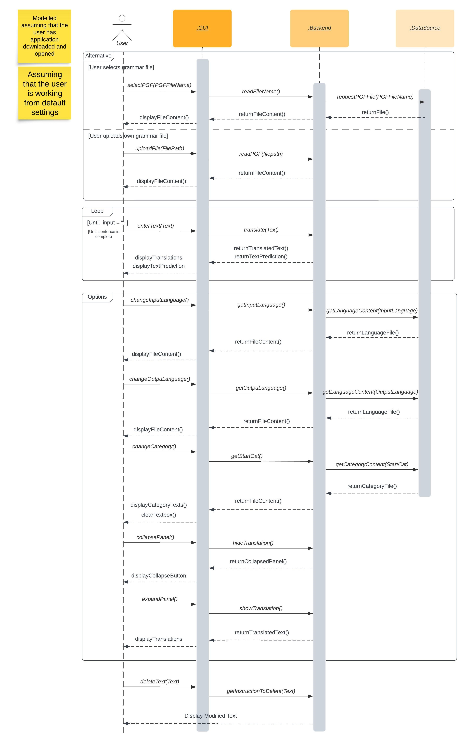

# **Project Plan**

# **Test Plan**

The test plan below indicates the preliminary cases that will be used to test the functionality of the app. This will be done using the input expected from the user, testing specific behaviours/features of the app and what the expected output of the behaviour from the input should be. The test cases were implemented from use cases mentioned in our use narratives and diagrams.

|  |  |
| --- | --- |
| Test Case No. | Test description + input, behaviour and expected output |
|  | Changing pgf grammar file |
|  | **Input**: select grammar file from collapsible panel  **Behaviour**: app’s ability to upload file from existing file system and load in the contents of the file. Extract all categories associated with .pgf and list them in category collapsible panel.  **Expected Outcome**:   1. Display empty textbox 2. display all words [string] that are contained in the .pgf related to selected category 3. Display new list of available categories associated with .pgf file. |
|  | Adding a grammar file |
|  | **Input:** adds .pgf file  **Behaviour:** app’s ability to upload file from user file system and load in the contents of the file. Extract the name of the file so that it can be listed in the list of available grammar files on gui. Extract all categories associated with .pgf and list them in category collapsible panel.  **Expected Outcome:**   1. Display empty textbox 2. Display file in collapsible panel. 3. Display all words that are contained in the .pgf related to selected category. 4. Display new list of available categories associated with pgf file. |
|  | Input Text |
|  | *Case 1: input 1 word a time*  **Input**: text [string]  **Behaviour**: the app’s ability to take in user input, verify that word exists in grammar file content and output to user.  **Expected Outcome**:   1. Display output text in own textbook. 2. display all possible words [string] that user can select   *Case 2: input a whole sentence*  **Input**: paste text  **Behaviour**: the app’s ability to verify that sentence contains words that exist in the pgf grammar file. Produce output to user.  **Expected Outcome**:  If sentence verified: all possible translations of sentence under collapsible.  else : Empty translation panel. no translation # inexistence of words in grammar file. |
|  | Predictive typing |
|  | **Input**: text [string]  **Behaviour**: the app’s ability to predict the next set of the words that the user can type in as input and display them.  **Expected output**: display set of words that the user might type next/select. |
|  | Delete words |
|  | **Input**: click backspace  **Behaviour**: the app’s ability to modify input string so that it removes any words that have been deleted by the user. Modify GUI such that the single word textbox that was created for word to be deleted is removed.  **Expected Outcome**:   1. word is removed from “screen” 2. Change prediction to what is expected to come at current word |
|  | Clearing all text |
|  | **Input:** click *clear*  **Behaviour**: the app’s ability to remove the currently words from the textbox and allow user to reselect or input new text.  **Expected Outcome**:   1. all words in file appear in “word” panel. 2. Textbox is cleared with cursor placed at textbox |
|  | Modify Translation Settings: Change "From” (source)Language |
|  | **Input**: select translation language  **Behaviour**: the app’s ability to translate selected/typed text from source language to selected language.  **Expected Outcome**: translation of sentence using selected language. |
|  | Modify Translation Settings: Change “To” Language |
|  | **Input:** select source language  ***Behaviour****:* the app’s ability to change the expected set of words to that of a different source language. Changes what the system expects as input.  **Expected outcome**: clear textbook, ready for user to start typing in source language. |
|  | View Translation |
|  | *Case: expand panel*  **Input**: click on collapsible button  **Behaviour**: the app’s ability to expand the panel when the button is clicked by extracting the language to sentence translations and output to the user.  **Expected Outcome:** drop down of all string translations with language on the far left and the translation next to it.  *Case: collapse panel*  **Input**: click on collapsible button  **Behaviour**: the app’s ability to collapse the panel when the button is clicked  **Expected Outcome:** hide all the words [string]that are currently showing in the translation panel. Just have “view translation” button. |
|  | Change Category |
|  | **Input**: select new category  **Behaviour**: the app’s ability to extract words associated with category and display on panel and change current category to the category that has been selected by user.  **Expected Outcome**:   1. output all words [string] related to the category. 2. Empty the textbox. |